**REACTION MECHANISM OF HOMOGENEOUS CATALYTIC SYSTEM**

**Submitted By: A.KUPPUCHAMY (19CHP032)**

**HOMOGENEOUS catalysis:**

Homogeneous catalysis Contribution of homogeneous catalytic process in chemical industry is significantly smaller compared to heterogeneous catalytic process, it is only about 17-20 %. But importance of homogeneous catalysis is increasing significantly. The significance of homogeneous catalysis is growing rapidly particularly in the area of pharmaceutical and polymer industry. Some of the important industrial processes include: 1. Oxidations of alkenes such as production of acetaldehyde, propylene oxide etc. 2. Polymerization such as production of polyethylene, polypropylene or polyesters. A new major development in homogeneous catalysis is the application of organometallic complexes as catalysts. The use of organometallic catalysts has revolutionized the homogeneous processes increasing economic viability. Another new area is bio-catalysis involving enzymes catalysts. In homogeneous catalysis, all the reactants and catalysts are present in a single fluid phase and usually in the liquid phase. Homogeneous catalysts are the simple molecules or ions such as HF, H2SO4, Mn+2 as well as complex molecules such as organometallic complexes, macrocyclic compounds and large enzyme molecules.

**Advantages**

Advantages of homogeneous processes can be summarized as follows:

* In many reactions, homogeneous catalysts are more active and/or selective compared to heterogeneous catalysts.
* In homogeneous catalysis, the catalysts are molecularly dispersed within the fluid. Hence, pore diffusion limitations are absent. However, bulk phase mass transfer limitation may occurs.
* Catalytic chemistry and mechanism for homogeneous catalysis are better studied and understood. Therefore, it is easier to control and manipulate the process parameters.

**Disadvantages**

However, homogeneous processes are also associated with some major disadvantages which result in limited use of these processes. These disadvantages are summarized below:

* Homogeneous catalysts are stable only in relatively mild conditions which limit their applicability.
* Since the catalysts are molecularly dispersed in the phase as the reactant, products and solvents, the separation at end of the process is difficult and expensive. In many cases, it is not possible to recover the catalyst.

**Types of reactions**

Several homogeneous catalytic systems are :

1. Acid base catalysis
2. Catalysis by metal ions
3. Catalysis by organometallic complexes
4. Catalysis by Lewis acids
5. Catalysis by porphyrin complexes
6. Catalysis by enzymes

## 

1. Catalysis by acids or bases

Acid –base catalysts are used in the following types of reactions:

1. Condensation
2. Dehydration
3. Hydrolysis
4. Halogenations

## Examples

## a) Acid catalyzed condensation

i. Acid catalyzed condensation of phenol and acetone to bisphenol which is an important intermediate in the manufacture of epoxy resin and polycarbonates.

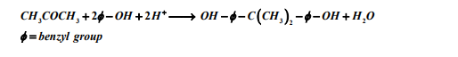

ii. Acid catalyzed synthesis of ethyl acetate ester from ethanol and acetic acid.



**b) Acid catalyzed dehydration of ethyl alcohol to ethylene**



**c) Hydrolysis of esters**

Hydrolyses of carboxylic esters to form the parent carboxylic acid and an alcohol.

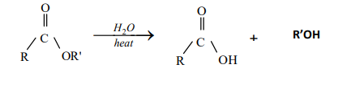

**d) Acid or base catalyzed halogenation**

Ketones can be halogenated in the presence of acid or base and X2(X= Cl, Br).

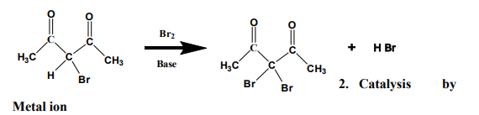

Metal ions can act as catalysts. Metal ions function in different ways :

* Metal ion can act as a “super acid”. It introduces positive charge into the substrate, making it more susceptible toward nucleophilic attack.
* Metal ions can also act as templates. Metal ions are able to coordinate to more than 2 ligands and thereby bring the molecules together.
* Metal ions can act as redox catalysts. Many metal ions can accept or donate electrons by changing their oxidation state and thereby participate in redox reactions.

**Examples**

**a) Catalysis by Cu2+  ions**

Cu2+ ions are very effective catalysts for the hydrolysis of α-amino acid esters.

** b) Catalysis by Mg2+  ions**

Hydrolysis of phosphate esters is catalyzed by metal ions, usually Mg2+.



### **3. Catalysis by organometallic complexes**

Presently, organometallic catalysts play major role in homogeneous catalysis. Organometallic complex consist of a central transition metal ion bonded to organic ligands such as R2C=CR2, RCO, R3P, R3N, CO etc. Catalysis occurs through dissociation of ligands followed by co-ordination of reactant molecule to the metal ion. The transition metal ions react through exchange of d electrons. Organometallic complexes usually have octahedral or tetrahedral geometry. Reactions catalyzed by organometallic complexes include hydrogenation, hydroformylation, carbonylation and decarbonylation, hydrocarbon rearrangement, partial oxidations etc.

### **Effect of ligands**

The nature of surrounding ligands is very important in organometallic catalysis and known as ligand effect. The product distribution depends on the ligand environment around the metal center. Using the same metal center, different products can be obtained with the same substrate when associated ligands are changed around the metal center.

### **Ligand types**

Phosphine based ligands ( PR3 ; where R= t-Bu, n-Bu, Ph, CH3O, CF3CH2O, Cl, CF3) are most widely used. The alkyl phosphines are strong bases and are σ donor ligands while the organophosphites, P(OR)3 , are strong π acceptors and form stable complexes with electron rich transition metal by accepting π electrons.

Other ligands that are used are discussed below :

* Hydrocarbyl group : Cyclopentadieneyl ligands (Cp) are associated with metals such as Ti, Zr, Hf . The Cp2TiCl2 catalyst is used in ethylene polymerization. Ruthenium complexes containing aromatic ligands are used for hydrogen transfer reactions such as transfer of hydrogen from alcohol to ketone producing another alcohol.
* Alkoxide, imides and imido are used as anionic ligands in zirconium and titanium catalysts for the polymerization of alkene. These are mostly used in combination with cyclopentadienyl ligands.
* Some other ligands such as phosphine with nitrogen substituents, carbon based ligands are also shown in Fig. 2.

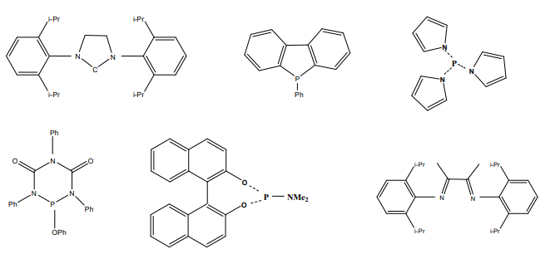

**Fig. 2. Examples of phosphorous, nitrogen and carbon based ligands**

### **4. Catalysis by Lewis acids**

### **a. Diels alder reactions**

### Reaction of diene with a mono-ene form cyclohexene derivativeis shown below.

### 

### **b.poxidation**

Epoxidation reaction is important reaction for producing organic intermediates. Alkenes can be transformed to epoxide by hyperoxides and catalysts. Catalysts are often titanium or molybdenum complex acting as Lewis acid.

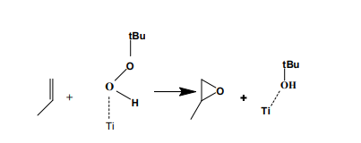

### **5. Catalysis by porphyrin complexes**

Porphyrin complexes are used to catalyze epoxidation and hydroxylation reactions. The porphyrins are macrocyclic compound. The porphyrin molecule contains fourpyrrole rings linked via methine bridges.The structure of porphyrin macro molecule is shown in Fig. 3. The porphyrin ring system is very stable and exhibits aromatic character. The porphyrin nucleus is a tetradentate ligand inwhich the space is available for a coordinating metal and has a maximum diameter of approximately 3.7 A0. When coordination occurs, two protons are removed from the pyrrole nitrogen atoms, leavingtwo negative charges. Various metals such as Na, K, Li Co, Ni, Cu, Fe, Mn form complexes.

**N**

**N**

**N**

**N**

**H**

**H**

**Fig 3.Structure of porphyrin macro molecule**

**Epoxidation**

The Ru(II)porphyrin complexes is used as epoxidation catalyst of olefins.Ruthenium(II) carbonyl tetraphenylporphyrinscatalyze epoxidation of olefins in the presence ofmetachloroperbenzoic acid as oxidants.

**Hydroxylation**

The hydroxylation of unactivated alkanes can be done inthe presence of iodosylbenzene and iron porphyrins catalyst. The oxidation of cyclohexane in presence of iodosylbenzenewith chloro(5,10,15,20-tetra-o-tolylporphyrinato)iron(III) [Fe(TTP)CI] producescyclohexanol andcyclohexanone as shown below.

